

**NMAM INSTITUTE OF TECHNOLOGY**

(A unit of Nitte Education Trust)

Nitte - 574 110, Karkala taluk, Udupi Dist., Karnataka

**Department of Computer Science and Engineering.**

**RDBMS PROJECT REPORT ON**

**METRO RAIL MANAGEMENT SYSTEM.**

***PROJECT ASSOCIATES***

**Manjunath Patkar Keerthesh S**

**4NM17CS100 4NM17CS087**

**V Sem, Sec 'B' V Sem, Sec 'B'**

**Dept of C.S.E Dept of C.S.E**

**PROJECT GUIDE**

**Ms.Anusha Anchan**

**Dept of C.S.E.**

**NMAMIT**

**ABSTRACT**

This is an integrated service which provide all information about the metro rail and it’s routes for public. The proposed system is a web based application which provides information regarding timings, routes, fair.

This system manages public feedback about services through it’s complaint management system. This system also contains an online ticket recharge module where users can recharge their smart cards online through the site.

There is also an admin module where admin can add stations, trains, routes and also update the fairs. The admin is a panel consisting of a group of authorized persons.

**TABLE OF CONTENTS**

**Chapter Page no.**

**1. CERTIFICATE 4**

**2. ACKNOWLEDGEMENT 5**

**3. INTRODUCTION 6-7**

**4. PROBLEM STATEMENT 8**

**5. DATABASE DESIGN**

**6. FRONT END TECHNOLOGY**

**7.BACK END TECHNOLOGY**

**8.SCREENSHOTS**

**9.CONCLUSION**

**10.REFERENCES**

**CERTIFICATE**

Certified that the project work carried out by Manjunath Patkar (4NM17CS087) and Keerthesh S(4NM17cs087) bonafide students of NMAM Institute of Technology, Nitte in fulfilment for the Relational database Management System lab in Computer Science and Engineering during the academic year 2019-2020.

Signature of the Examiners:

Signature of the Guide:

1.

2.

**ACKNOWLEDGEMENT**

The satisfactions that accompany the successful completion of any task would be incomplete without the mention of the people who made it possible. So we acknowledge all those whose guidance and encouragement served as a beacon of light and crowned our efforts with success.

We are thankful to our project guide, Ms. ANUSHA ANCHAN, Dept. of CSE for his valuable guidance and advice. His willingness to motivate us contributed tremendously to our project.

We would like to place on record our deep sense of gratitude to Dr. K. R. Udaya Kumar Reddy, HOD-Dept. of Computer Science and Engineering, NMAMIT, Nitte for his generous guidance, help and useful suggestions. We also acknowledge and express our sincere thanks to our beloved Dr. Niranjan. N. Chiplunkar, Principal, NMAMIT, Nitte who is a source of inspiration to us.

We thank all the Teaching and Non-Teaching staff members of the department of CSE for providing resources for the completion of the project. A special thanks goes to our parents, friends and relatives for supporting and encouraging us in all ways thus making our project

successful. Finally, we thank all those who have contributed directly or indirectly in making this project a grand success.

Manjunath Patkar Keerthesh S

(4NM17CS100) (4NM17CS087)

**CHAPTER 3**

**INTRODUCTION**

This is an integrated service which provide all information about the metro rail and it’s routes for public. The proposed system is a web based application which provides information regarding timings, routes, fair. This system manages public feedback about services through it’s complaint management system. This system also contains an online ticket recharge module where users can recharge their smart cards online through the site.

There is also an admin module where admin can add stations, trains, routes and also update the fairs. The admin is a panel consisting of a group of authorized persons.

**OBJECTIVE**

. The objectives of the project are as follows:

* Users can register complaints through the site.
* User login page where users can recharge tickets online.
* Users can view metro timetable.
* User can also view the fair details and the route map.
* An admin login page where admin can add stations, trains,routes , update fairs and even add a new admin.

**Product Description**:

Metro rail management system is an online system which helps the user to recharge their tickets online, it also have a complaint management system in which users can register their complaints online.

By visiting the site the users can get metro time table. Other than that by entering the source station and destination station the users can get all sorts of information about trains arriving and departing from the stations, it’s fair details and even it provides you the route map.

**CHAPTER 4**

**PROBLEM STATEMENT**

**Problem Statement**:

The problem occurred before having online system includes: ➢ File lost

When online system is not implemented the complaints are reported in files. The files are always lost due to some human errors.

* Time consuming

When there is no computerized system then for recharge purposes the users need to travel to the stations and also sometimes even need to stand in large queues for recharge purposes.

* Most updations are unnoticeable

When online systems is not implemented any changes in fair, timings etc when updated ,the details of these things are only available at the stations.

***SYSTEM OBJECTIVES***

* Improvement in Control and performance

The system is developed to cope up with current issues and problems of the metro rail. The system helps to recharge online, make a complaint online , display metro timetable ,fairs and route maps.

* Save time

User is able to recharge online, see details of metro time table , fairs & route maps and even the user can complaint online there by saving his valuable time.

* Easy to Use

A person with just an internet connection and a pc can do things such as complaint, recharge and view metro details very easily.

**CHAPTER 5**

**ER-Diagram**

**RELATIONAL DATABASE SCHEMA**

CUSTOMER

|  |  |  |  |  |  |
| --- | --- | --- | --- | --- | --- |
| Username | Fname | Lname | Address | Phone_No | Password |

ADMIN

|  |  |  |  |  |  |
| --- | --- | --- | --- | --- | --- |
| Admin_Id | Admin_Name | Age | Sex | Email | Password |

SMARTCARD

|  |  |  |  |  |
| --- | --- | --- | --- | --- |
| Card_No | Balance | Card_status | Username | Admin_Id |

ROUTE

|  |  |
| --- | --- |
| Route_Id | Route_Name |

STATION

|  |  |
| --- | --- |
| Station_Name | Route_Id |

TRAIN

|  |  |  |
| --- | --- | --- |
| Train_Id | Admin_Id | Route_Id |

COMPLAINT

|  |  |  |  |  |
| --- | --- | --- | --- | --- |
| Comp_Id | Comp_Subject | Comp_Desc | Comp_status | Username |

EMAIL

|  |  |
| --- | --- |
| Username | Email |

DISPLAY_STATUS

|  |  |  |  |  |
| --- | --- | --- | --- | --- |
| From_Station | To_Station | Train_Id | Arrival | Departure |

**CHAPTER 6**

**FRONTEND TECHNOLOGY**

**List of technologies for frontend**

**1. Hyper Text Markup Language(HTML)**

Hypertext Markup Language is the standard markup language for creating web pages and web applications.

**2. Cascading Style Sheets(CSS)**

Cascading Style Sheets is a style sheet language used for describing the presentation of a document written in a markup language like HTML

**3. JavaScript**

JavaScript, often abbreviated as JS, is a high-level, interpreted programming language. It is a language which is also characterized as dynamic, weakly typed, prototype-based and multi-paradigm.

**CHAPTER 7**

**BACKEND TECHNOLOGY**

**List of technologies for Backend**

**1.PHP**

Hypertext Preprocessor is a server-side scripting language designed for Web development, and also used as a general-purpose programming language. It was originally created by Rasmus Lerdorf in 1994, the PHP reference implementation is now produced by The PHP Group.

**Database:**

**MySQL:**

MySQL is an open-source relational database management system. Its name is a combination of "My", the name of co-founder Michael Widenius's daughter, and "SQL", the abbreviation for Structured Query Language.

**CHAPTER 8**

**SCREENSHOTS**

**HOME PAGE:**

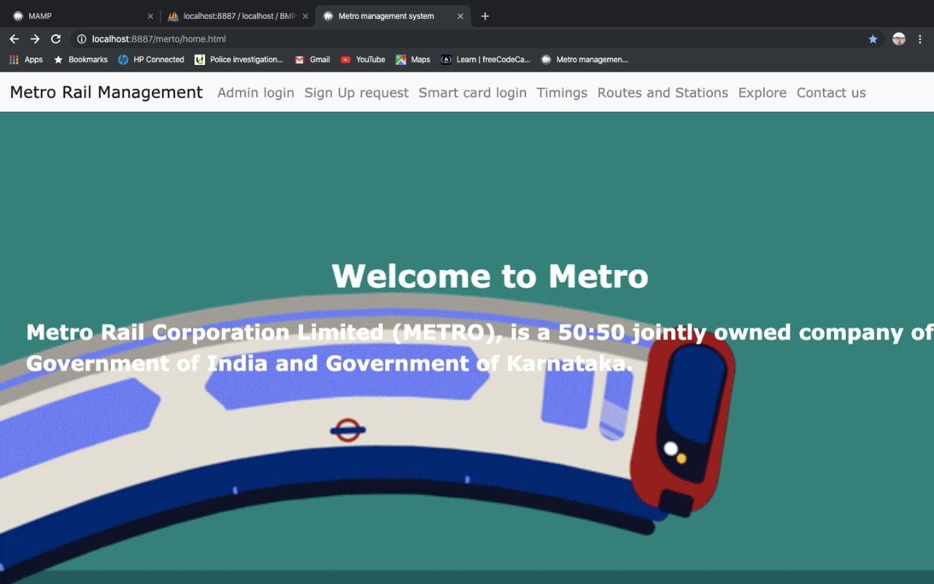

**ADMIN LOGIN:**

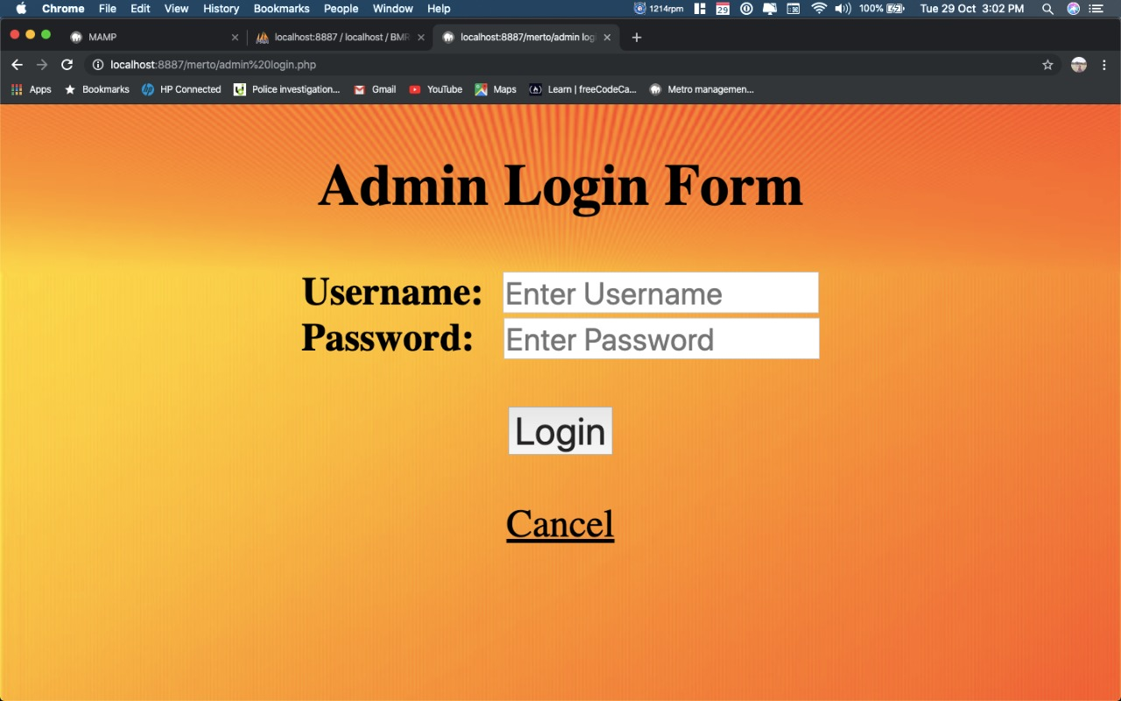

**ADMIN LOGIN:**

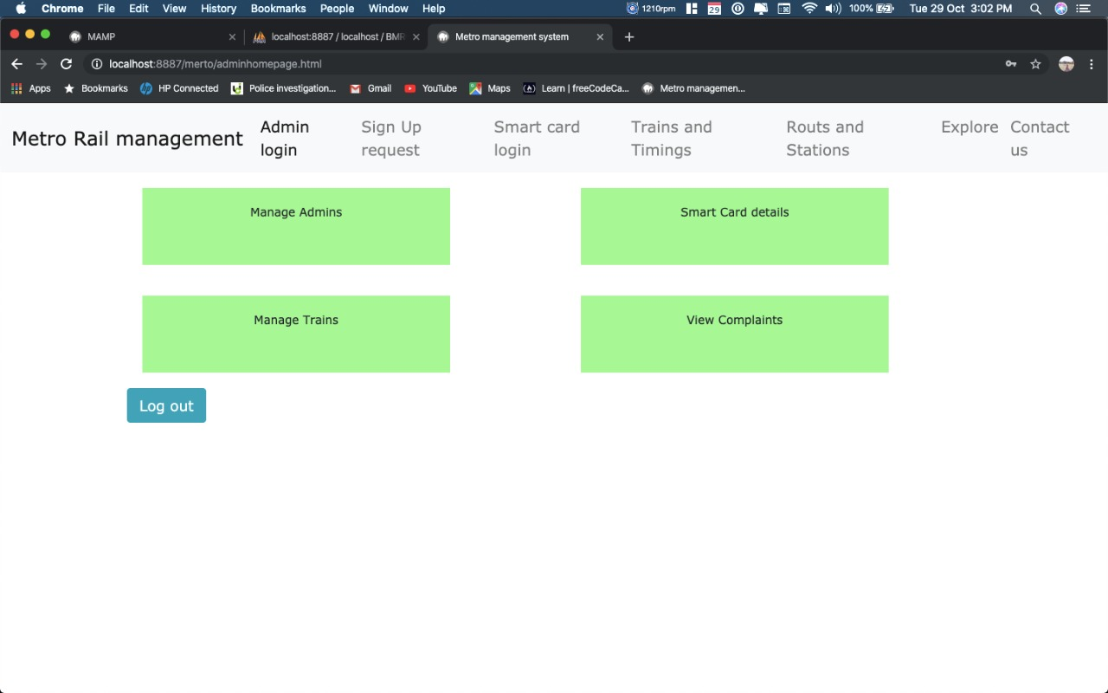

**MANAGE ADMINS:**

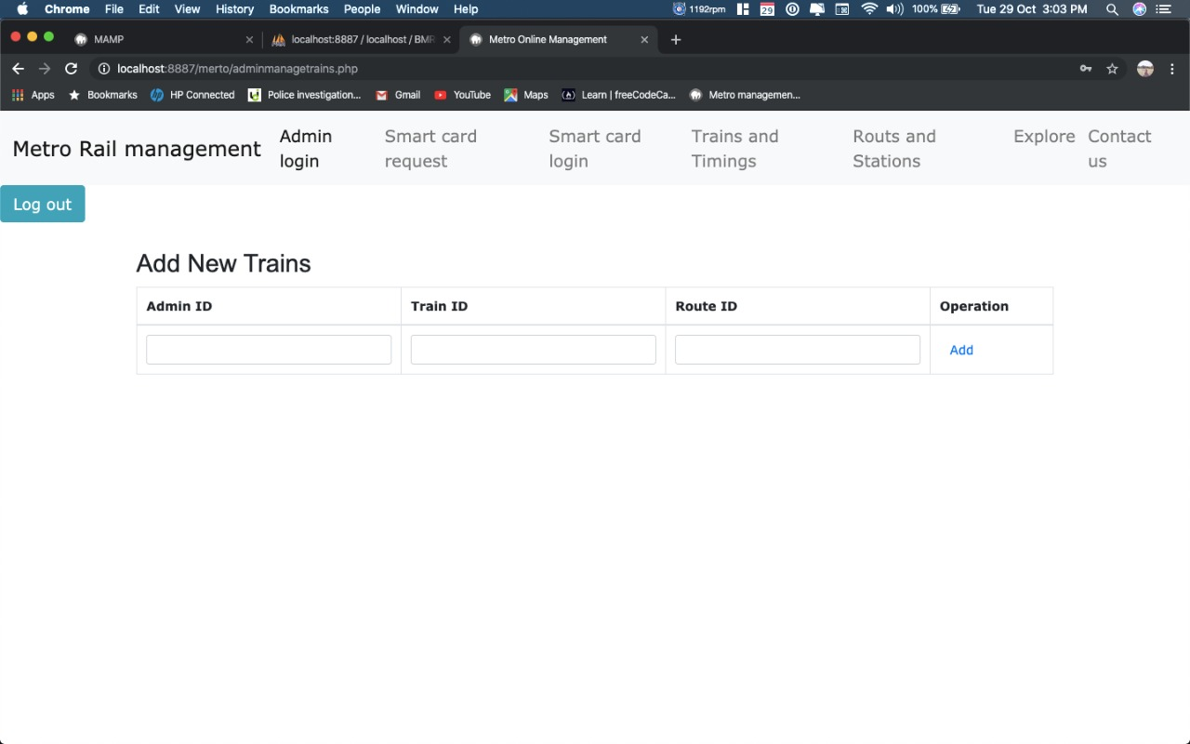

**SMART CARD DETAILS:**

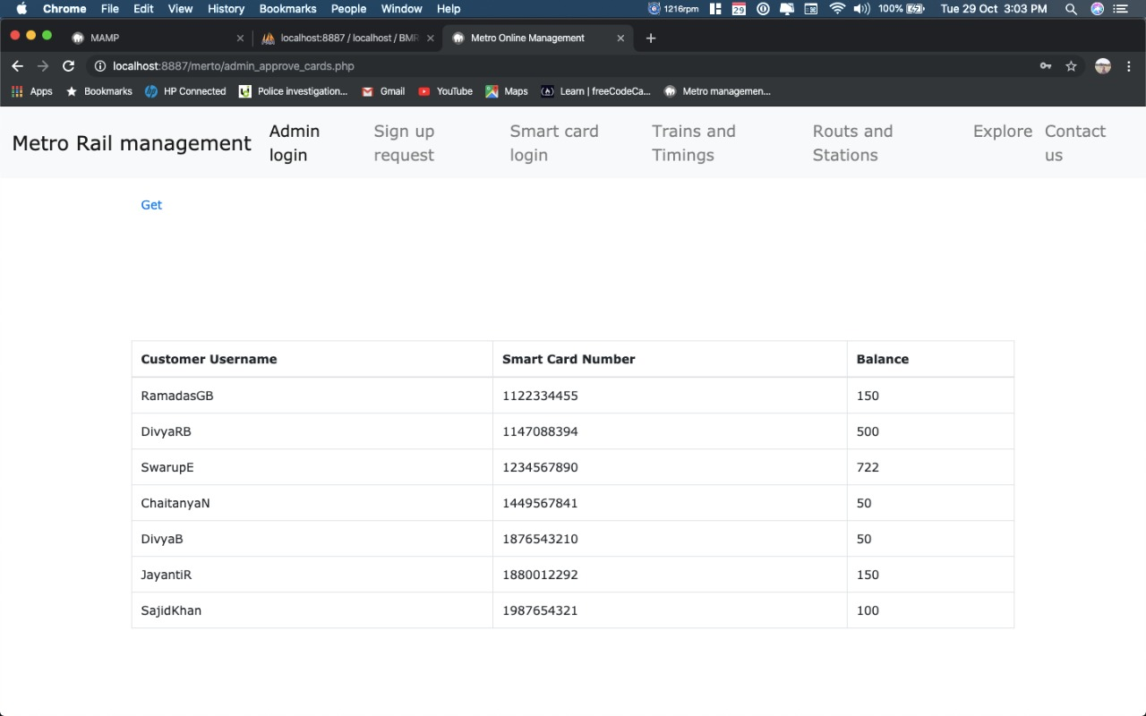

**MANAGE TRAINS:**



**VIEW COMPLAINTS:**

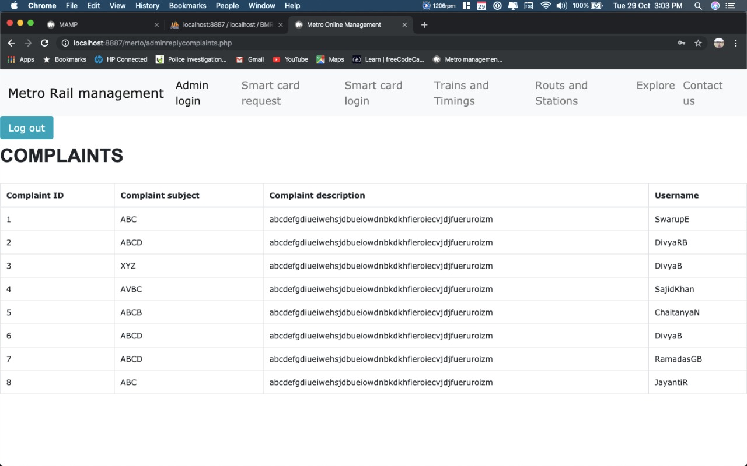

**SIGN UP PAGE:**

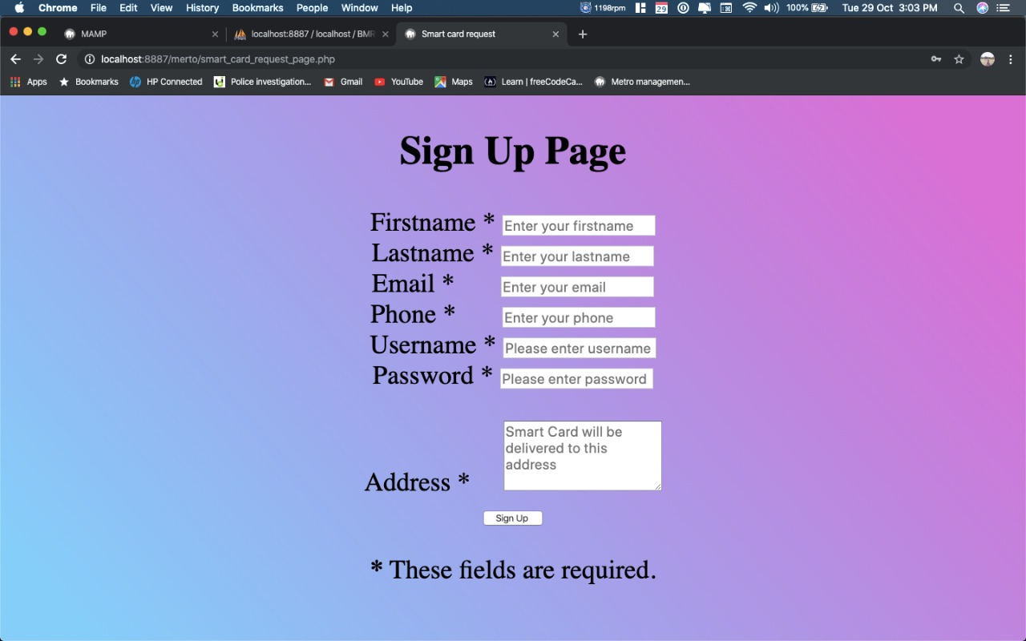

**SMART CARD LOGIN:**

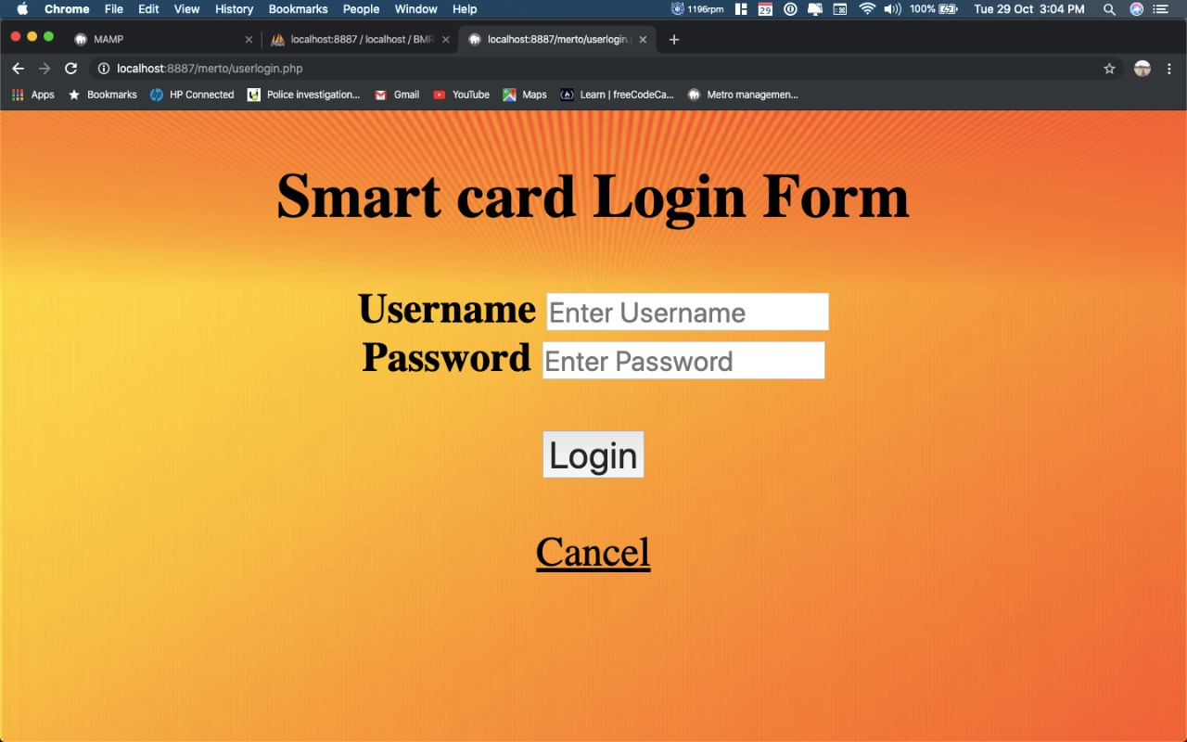

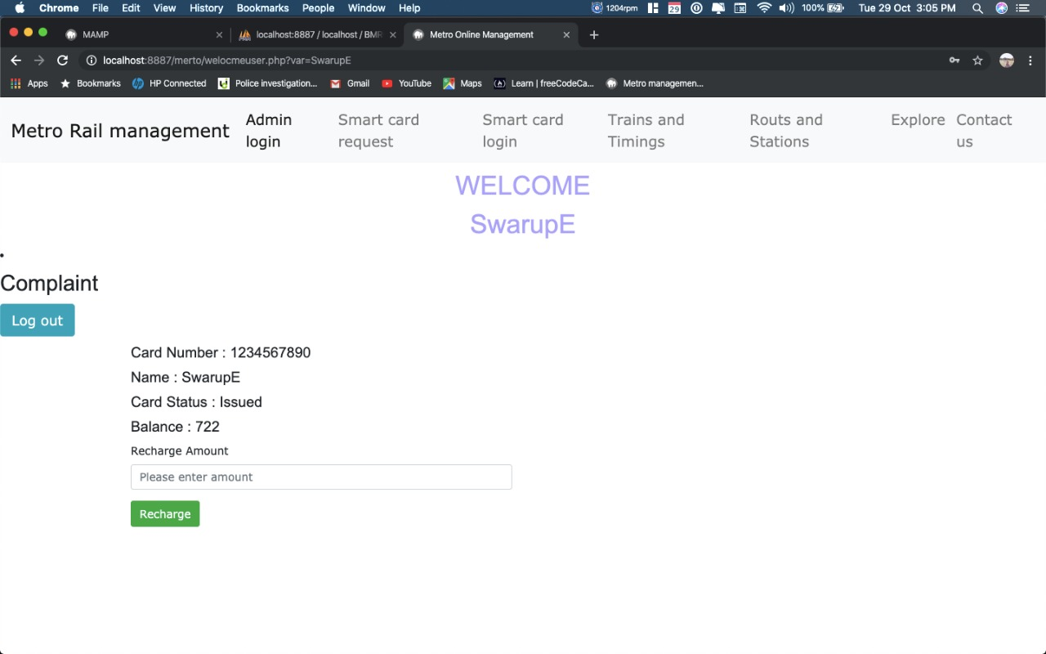

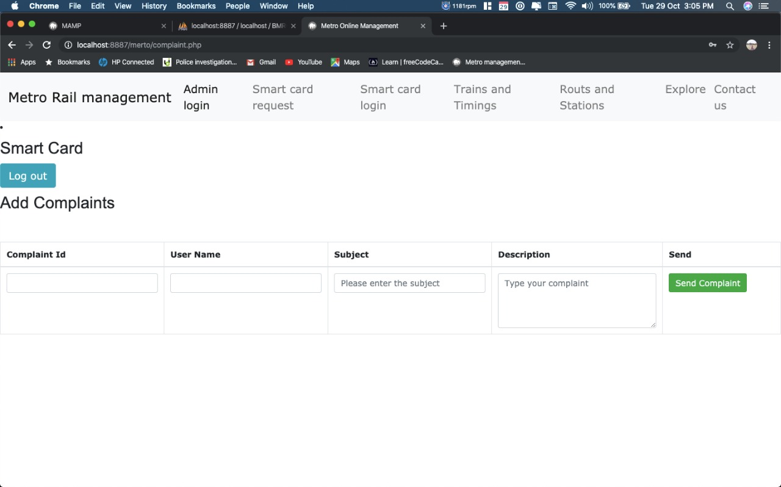

**TRAINS AND TIMINGS:**

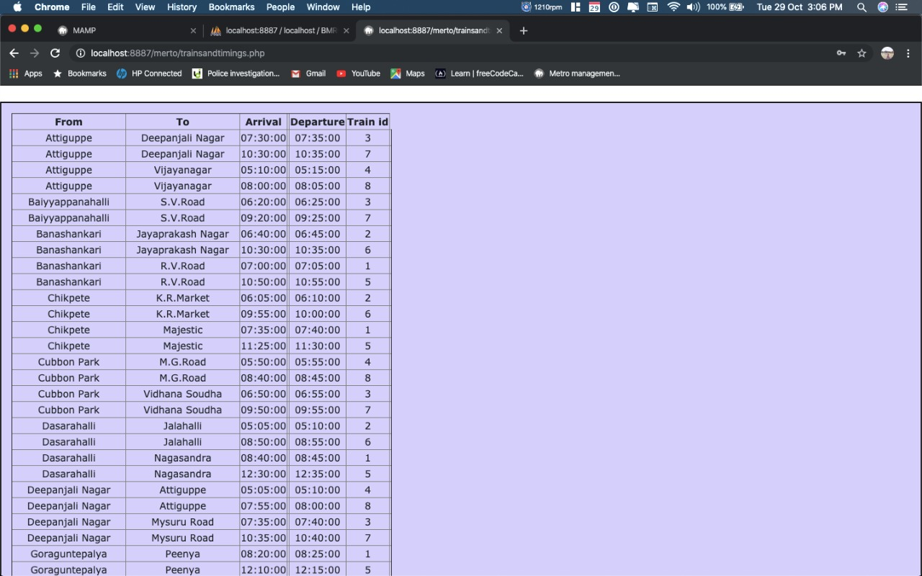

**ROUTES AND STATIONS:**

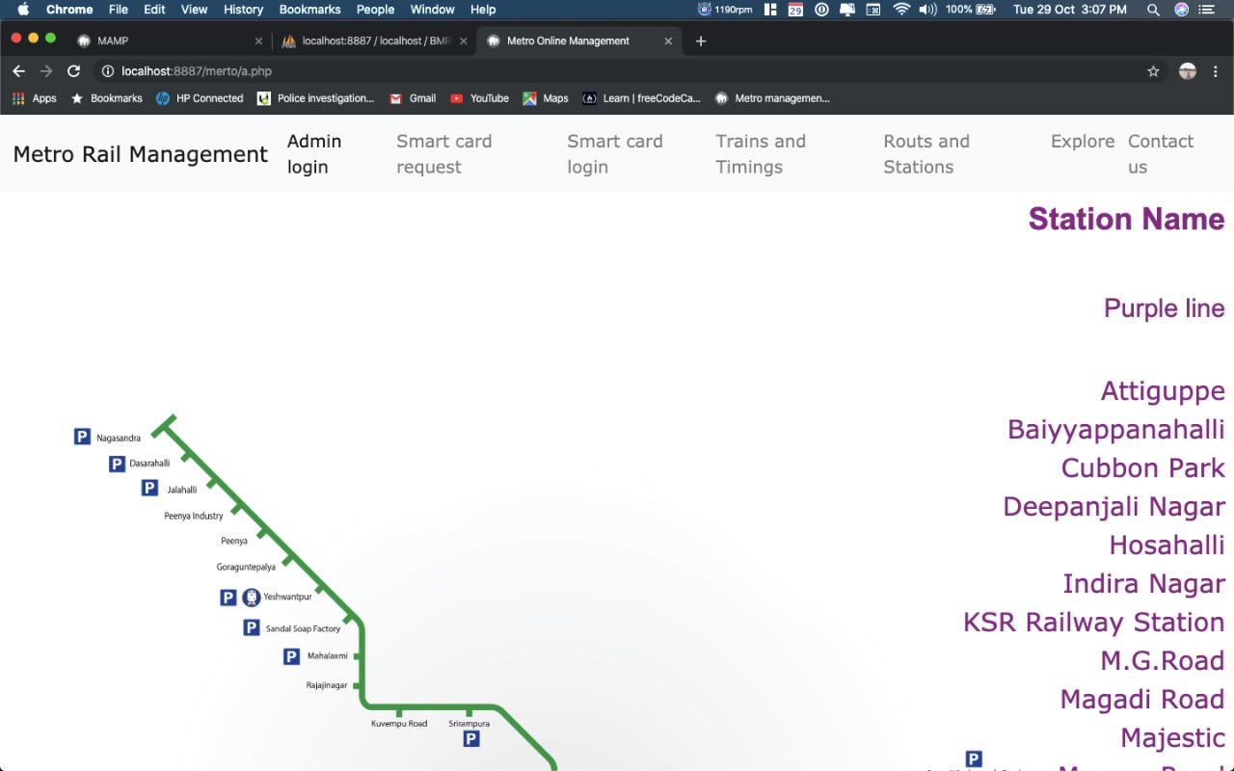

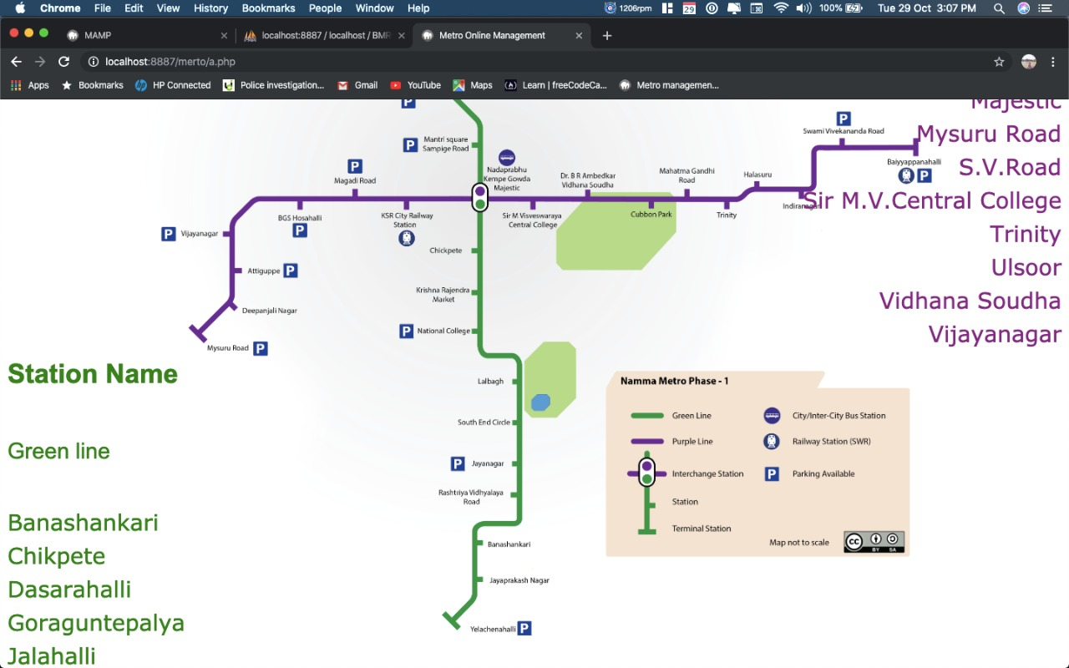

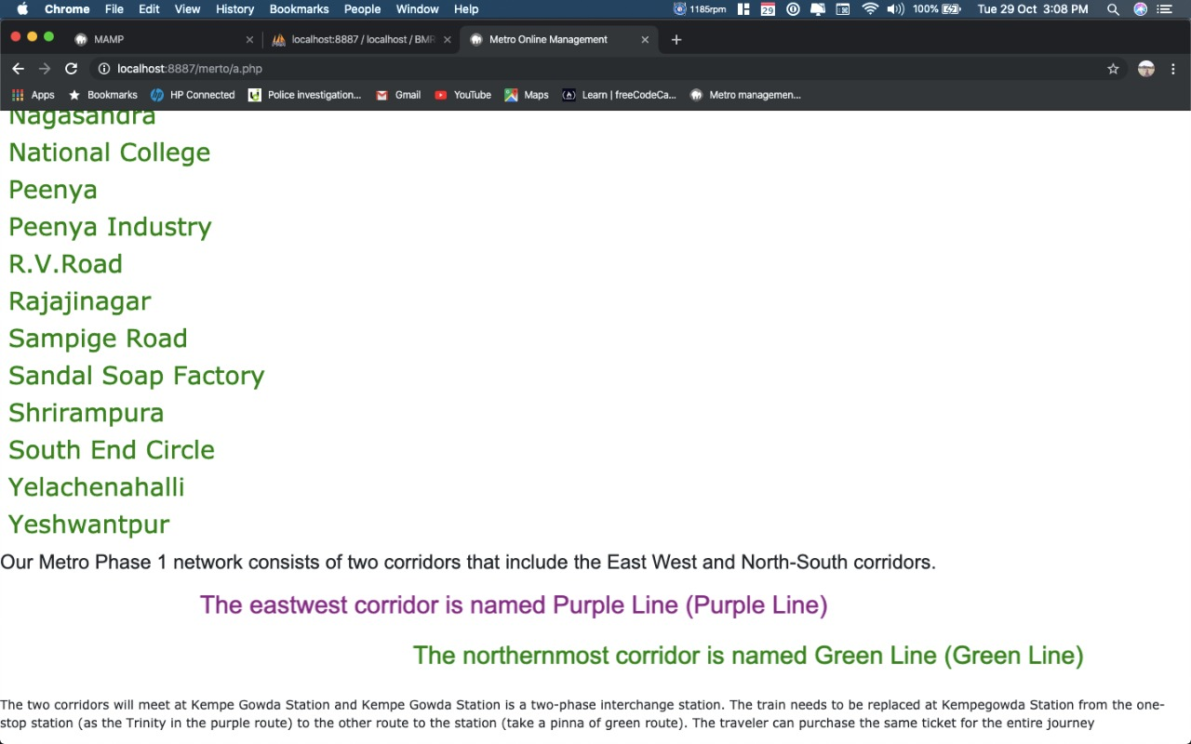

**EXPLORE:**

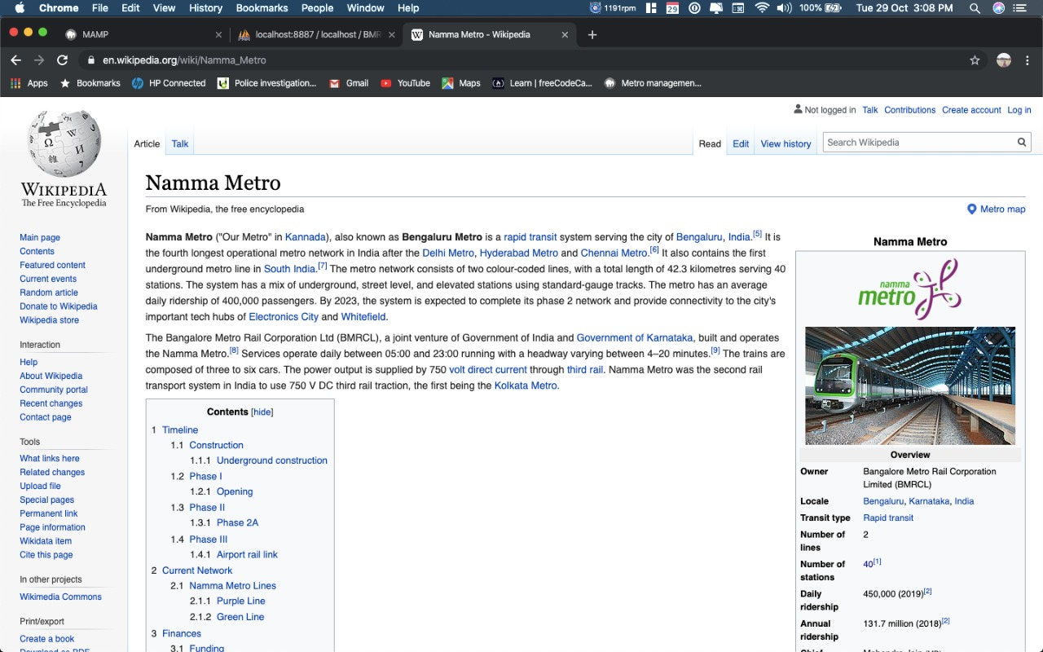

**CONTACT:**

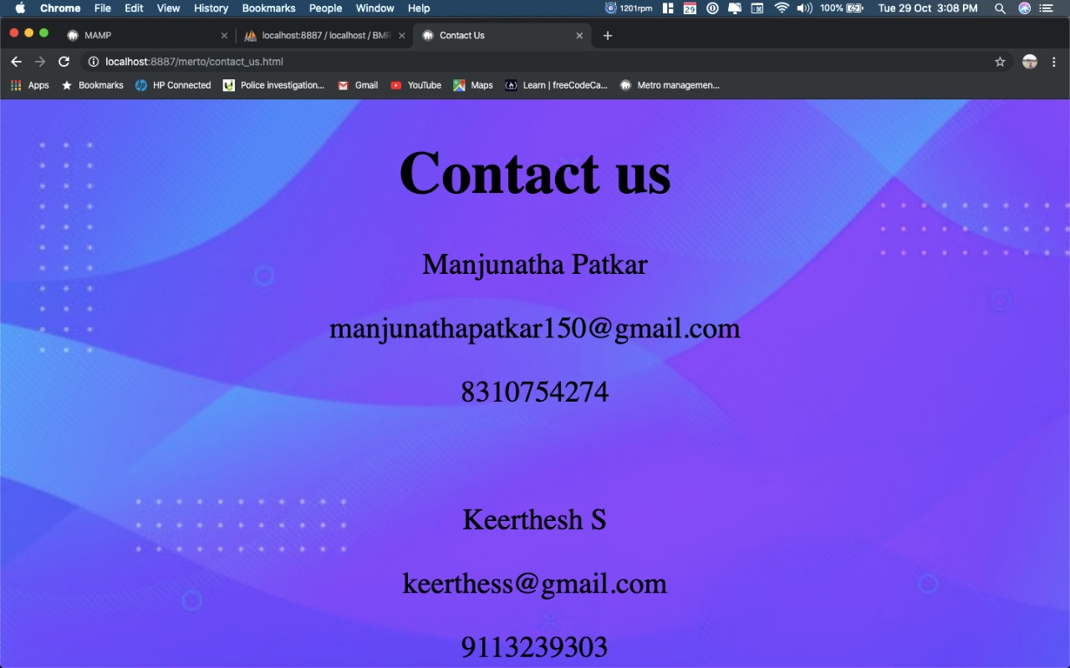

**CHAPTER 9**

**CONCLUSION**

The project entitled **Metro Rail Management System** was completed successfully.

The system has been developed with much care and free of errors and at the same time it is efficient and less time consuming. The purpose of this project was to develop a web application for metro rail management

This project helped us in gaining valuable information and practical knowledge on several topics like designing web pages using html &css, usage of responsive templates, designing of android applications, and management of database using mysql . The entire system is secured. Also the project helped us understanding about the development phases of a project and software development life cycle. We learned how to test different features of a project.

This project has given us great satisfaction in having designed an application which can be implemented to any nearby shops or branded shops selling various kinds of products by simple modifications.

There is a scope for further development in our project to a great extend. A number of features can be added to the system in future like watch me module, each admin having separate permissions.

**CHAPTER 10**

**REFERENCES**

**1.** [**www.stackoverflow.com**](http://www.stackoverflow.com)

**2.** [**www.youtube.com**](http://www.youtube.com)

**3.** [**www.w3schools.com**](http://www.w3schools.com)